May newsletter

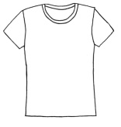
Please can we remind parents that your child needs to wear the correct uniform with Diamond preschool logo. If you require to buy more, jumpers are £7 and T-shirts are £4. These are available at preschool.

This year our summer trip we will be going to LEGOLAND discovery centre in Birmingham. There will be a separate letter with all the details.

Term dates
Close: Monday 6th May (Bank holiday)
Close: Friday 24th May-open June 3rd
Close: Friday 19th July
Open: September 4th

